

Plant Operation of Inverters

Version 0.01

Produced by Dave Robinson

March 2023

Table of Contents
1 Table of Contents ii
1.1 Revision History iii
2 Introduction 4
2.1 Background 4
2.2 Purpose 5
3 Requirements 5
3.1 High level features 5
4 Design 7
4.1 Power balance calculation 7
4.2 Power share across a plant 8
4.3 Inverter Power Calculation 8
4.4 Power balance Modbus registers 9
4.5 Plant Summary Modbus Registers 10
4.6 Plant Controller Portal 13
5 Appendix A – Current protocols 16
6 A1 GivEnergy inverter to cloud protocol V1 16
7 A2 GivEnergy battery to cloud protocol V1 16
8 A3 OB115 to cloud protocol V1 16
8.1 Appendix B – Protocol timings 17
9 B1 Telemetry protocol 17

Revision History
Name | Version | Date | Overview
Initial | 0.01 | 06/03/2023 | Initial draft version

Introduction

Background
The main purpose of a battery and inverter installation in a residential setting is to reduce a customer’s electricity bill with a grid energy supplier. This is achieved by either minimising energy imported from the grid, or buying energy from the grid at optimal unit rates (E.g. economy 7)
Minimising the amount of energy imported from the grid is achieved by:
- Powering a property with solar energy
- Powering a property with energy stored in batteries.
- Powering a property with solar energy and battery energy when property power consumption exceeds what is available from solar.
- Ensuring batteries are charged at optimal tariffs.
  - Excess solar energy (free)
  - Optimal grid rates (Economy 7 or similar)
- Ensuring that batteries are only discharged by the real-time needs of the property.
The last point is key as a battery providing more power than a property needs will waste battery energy and result in unnecessary power being exported to the grid.
GivEnergy inverters currently manage the real-time control loop that monitors house power consumption, and solar generation to optimally charge and discharge batteries. The control loop of a GivEnergy residential inverter is 250ms*
GivEnergy inverter reaction time is up to 1 second*.
The tolerance that a GivEnergy inverter can control the charge and discharge power level is +/- 2.5%*
GivEnergy inverters have a maximum power rating which determines how much energy can be provided to a property or how much energy can be used to charge a battery. In cases where an inverter power rating is not sufficient for a property or cases where extra battery storage is required without compromising on charge time, there is a requirement to support multiple inverters operating in parallel. The remainder of this document will refer to this mode of operation as “Plant”. A typical issue encountered with a parallel inverter installation is battery cross charging. Inverters must operate in collaboration to share load and battery charging power to avoid one battery charging another, or too much power being generated and thus exported. Current inverter firmware does not support this mode of operation.
Inverter firmware source code is not available so GivEnergy UK will need a solution that can work with existing inverter firmware.
The plant system will need to operate within the G99 and G100 specifications to limit export power within 5 seconds and also meet the failsafe requirements of the standards.

*Info from China. DR to check.

Purpose
The purpose of this project is to provide a solution for GivEnergy customers to install multiple inverters in parallel as a plant and realise optimal power savings. It is perceived that the initial plant hardware control platform will be EMS which will be superseded by a GivEnergy home hub in future.

Requirements

High level features
Feature | Notes | Phase
Less than 1 second control loop of plant inverters (Reaction Time) |  | 1
Limit export power to zero within 5 seconds (G100) | Will only work reliably for installs with no solar (EMS cannot control what happens to solar generation when the batteries are full). | 1
Meet G100 failsafe requirements | Inverters stop generating power when communication with EMS is lost | 1
Minimise unnecessary import of energy to less than 100W/h per day |  | 1
Minimise unnecessary export of battery energy to 100W/h per day. |  | 1
Plant control hardware to send summary telemetry for meters, BMS, and inverters. |  | 1
Plant control hardware to support remote firmware update |  | 1
Plant control hardware to support remote firmware update of GivEnergy inverters and batteries |  | 3 – Would rely on China supporting firmware update over rs485
Plant control hardware to support distributing debug message to individual inverters and batteries |  | 2/3/4 – Cloud protocol can only distinguish between endpoints by modbus ID, and the UI only supports a single device.
Support multiple inverters in parallel |  | 1 – Maximum of 3 inverters
Support GivEnergy Inverters |  | 1 – AC couple inverters only
Support RTC |  | 1 – Hardware has no ability to save time
Support charging of batteries at a defined time of the day | Batteries in the plant should only charge from the grid when programmed to. | 1
Support discharge of batteries at a defined time of the day
Support charging of batteries from excess solar energy |  | 1
Support an optimisation profile. | Customers can choose whether to optimise generation or minimise grid import. | 2 – Phase 1 will determine how accurate we can get the inverters to operate.
Support remote configuration of EMS | Meter Count  Inverter Count | 2
Support auto detection of attached inverters and batteries | EMS support auto detect inverter numbers via RS-485 | 1 – Inverters and meters will be auto detected.
Present plant summary information of all meters and inverters in the system | Inverter SOC  Inverter temperature  Inverter active power  Meter active power  Active battery power  Active grid power  Active gen power  Calculate load power  Detailed inverter and battery information to come from individual inverters | 1

Design

Power balance calculation
PGrid = Power from AC Grid
PGen = Generated power (E.g. Wind or solar)
PBatt = Converted battery power
PBatt_total = Sum of all converted battery power in the plant
PInv = Individual Inverter Power
MaxBattPower = Maximum power that a battery can charge/discharge
BattCapacity = Usable battery capacity when fully charged.
MaxInvPower = Maximum power that an inverter provide.

n = number of inverters

The basic equation used for balancing power demand with battery power:
PBal = PGrid + (PBatt0..PBatt1n)
PGrid | PGen | PBatt_total |  | Total House Consumption | Battery Power to zero grid power (PBal) | Notes
5 | 0 | 5 |  | 10 | 10
-5 | 0 | 5 |  | 0 | 0
1000 | 2000 | 500 |  | 3500 | 1500
-500 | 2000 | 500 |  | 2000 | 0
-700 | 0 | 0 |  | 0 | -700 | Must be some other property generation
-700 | 700 | 0 |  | 0 | -700
-200 | 700 | 100 |  | 600 | -100
0 | 700 | 100 |  | 800 | 100
-700 | 0 | -700 |  | 0 | -1400
Note: PGen is not used in the PBal calculation

Power share across a plant
PBal should be shared across the plant to optimally charge and discharge batteries in the plant.

Phase1.
Inverter power level across the plant will be share equally when battery SOCs are within 1% using a simple calculation of:
PBatt = PBal / n.

Phase1.
When battery SOC variance is greater than 1% inverter power level across the plant will be programmed to balance battery SOC. E.g. when charging, batteries with the lowest SOC will charge first.
Firmware will try and keep all batteries in the plant at the same charge level.

Phase 2.
A two stage algorithm to set inverter power.
- Big power adjustments performed by calculation (Phase1)
- Small tweaks when grid power is +/- 100W

Inverter Power Calculation
Firmware will need to calculate MaxBattPower using the following equation.
MaxBattPower = MIN((BattCapacity * 0.5), MaxInvPower) ;

No electronics are 100% efficient. Firmware will need to adjust the inverter power level to meet a property power requirement while also taking into consideration inverter efficiency.

Basic testing has indicated that a 100% charge rate of a battery will result in close to a full MaxBattPower charge rate. Basic testing has indicated that a 100% discharge rate of a battery will result in 94% actual generated power although the efficiency will vary with load and temperature.

Power balance Modbus registers

The Plant Controller will determine live inverter battery power using input register 52
The Plant Controller will determine live inverter battery soc using input register 59
The Plant Controller will determine inverter maximum power using the least significant byte of holding register 2.
The Plant Controller will determine inverter battery maximum power using holding register 55 divided by two (0.5c)
The Plant Controller will control live inverter power settings using:
- Register 50 – Power level 0-100
- Register 96 – Charge Enable
- Register 59 – Discharge Enable

Plant Summary Modbus Registers

Plant Controller Identification
Initial plant reporting to the cloud will work within the limits of the existing portal protocol.
To allow the Givenergy portal to detect the plant controller, firmware will implement holding register 0 with a device code value of 0x5001.

Plant summary information
To allow customers to view summary information of all inverters, batteries, and meters in a single portal graph, the plant controller will implement a new register set starting at register 2,040. The plant controller will automatically send this register set as input registers (Command 4).

Reg | Name | Description | Value | Unit | Note
2040 | Plant Controller Status | Internal plant controller status |  | U16 | 0 = Waiting/Disabled  1 = Normal  2 = Warning  3 = Fault  4 = Flash (FW Update)
2041 | MeterCount | Number of meters detected | 0-8 | U16 | The plant must always see at least one grid meter to enter normal plant mode
2042 | MeterTypes | Bitmap of meter types |  | U16 | 00 = Grid, 01 = Gen, 10 = load, 11 = Other battery/Vehicle  Meter0 – bits 0-1  …  Meter7 – bits 14-15
2043 | MeterStatuses | Bitmap of meter status |  | U16 | 00 = Disabled, 01 = Online, 02 = Offline  Meter0 – bits 0-1  …  Meter7 – bits 14-15
2044 | InverterCount | Number of inverters detected | 0-4 | U16 | The plant must always see at least one inverter to enter normal plant mode
2045 | InverterStatuses | Bitmap of inverter status |  | U16 | 000 = Disabled, 001 = Waiting, 010 = Online, 011 = Warning, 100 = Error, 101 = Flash, 111 = offline  Inveter0 – bits 0-2  …  Inverter3 – bits 09-11
2046 | Meter1ActivePower | Power reported by meter1 | -32768 to 32767 | S16 | Watts
2047 | Meter2ActivePower | Power reported by meter2 | -32768 to 32767 | S16 | Watts
2048 | Meter3ActivePower | Power reported by meter3 | -32768 to 32767 | S16 | Watts
2049 | Meter4ActivePower | Power reported by meter4 | -32768 to 32767 | S16 | Watts
2050 | Meter5ActivePower | Power reported by meter5 | -32768 to 32767 | S16 | Watts
2051 | Meter6ActivePower | Power reported by meter6 | -32768 to 32767 | S16 | Watts
2052 | Meter7ActivePower | Power reported by meter7 | -32768 to 32767 | S16 | Watts
2053 | Meter8ActivePower | Power reported by meter8 | -32768 to 32767 | S16 | Watts
2054 | Inverter1ActivePower | Power reported by inverter 1 | -32768 to 32767 | S16 | Watts
2055 | Inverter2ActivePower | Power reported by inverter 2 | -32768 to 32767 | S16 | Watts
2056 | Inverter3ActivePower | Power reported by inverter 3 | -32768 to 32767 | S16 | Watts
2057 | Inverter4ActivePower | Power reported by inverter 4 | -32768 to 32767 | S16 | Watts
2058 | Inverter1SOC | State of charge | 0-100 | U16 | percent
2059 | Inverter2SOC | State of charge | 0-100 | U16 | percent
2060 | Inverter3SOC | State of charge | 0-100 | U16 | percent
2061 | Inverter4SOC | State of charge | 0-100 | U16 | percent
2062 | Inverter1Temperature | Inverter temperature | -40-200 | S16 | 0.1 degrees
2063 | Inverter2Temperature | Inverter temperature | -40-200 | S16 | 0.1 degrees
2064 | Inverter3Temperature | Inverter temperature | -40-200 | S16 | 0.1 degrees
2065 | Inverter4Temperature | Inverter temperature | -40-200 | S16 | 0.1 degrees
2066 | Inverter1_SN_1 | INV Serial number 1 | ASCII | U16
2067 | Inverter1_SN_2 | INV Serial number 2 | ASCII | U16
2068 | Inverter1_SN_3 | INV Serial number 3 | ASCII | U16
2069 | Inverter1_SN_4 | INV Serial number 4 | ASCII | U16
2070 | Inverter1_SN_5 | INV Serial number 5 | ASCII | U16
2071 | Inverter2_SN_1 | INV Serial number 1 | ASCII | U16
2072 | Inverter2_SN_2 | INV Serial number 2 | ASCII | U16
2073 | Inverter2_SN_3 | INV Serial number 3 | ASCII | U16
2074 | Inverter2_SN_4 | INV Serial number 4 | ASCII | U16
2075 | Inverter2_SN_5 | INV Serial number 5 | ASCII | U16
2076 | Inverter3_SN_1 | INV Serial number 1 | ASCII | U16
2077 | Inverter3_SN_2 | INV Serial number 2 | ASCII | U16
2078 | Inverter3_SN_3 | INV Serial number 3 | ASCII | U16
2079 | Inverter3_SN_4 | INV Serial number 4 | ASCII | U16
2080 | Inverter3_SN_5 | INV Serial number 5 | ASCII | U16
2081 | Inverter4_SN_1 | INV Serial number 1 | ASCII | U16
2082 | Inverter4_SN_2 | INV Serial number 2 | ASCII | U16
2083 | Inverter4_SN_3 | INV Serial number 3 | ASCII | U16
2084 | Inverter4_SN_4 | INV Serial number 4 | ASCII | U16
2085 | Inverter4_SN_5 | INV Serial number 5 | ASCII | U16
2086 | CalculatedLoadPower | Total Load calculated from meters and inverters | 0-65,535 | U16 | Watts
2087 | MeasuredLoadPower | Total Load measured from load meters | 0-65,535 | U16 | Watts
2088 | TotalGenPower | Total power from generation meters | 0-65,535 | U16 | Watts
2089 | GridPower | Power measured from grid meter | -32768-32768 | S16 | Watts
2090 | TotalBatteryPower | Total active power from Givenergy inverters in the plant | -32768-32768 | S16 | Watts
2091 | SystemWhRemaining | Total Wh of battery power remaining in the system | 0-65,535 | U16 | Wh
2092 | WarningBitmap | Bitmap of Plant Controller warnings | 0-65,535 | U16
2093 | ErrorBitmap | Bitmap of Plant Controller errors | 0-65,535 | U16
2094 | TotalOtherBatteryPower | Power measured from all “other” battery sources meters. | -32768-32768 | S16 | Watts. This register represents the active power being imported or exported to other battery sources. E.g. Vehicles via a car charger.
2095 | ModbusErrorCounter | A count of total modbus errors since startup. | 0-65,535 | U16 | Could be used by support to detect possible faulty wiring.

Plant Totals Energy Usage
EMS will utilise existing registers for reporting total energy consumption across the plant. The registers used are input registers (Command 4) 0-59follows:
Reg | Name | Description | Value | Unit | Note
0 | Plant Controller Status | Internal plant controller status |  | U16 | 0 = Waiting/Disabled  1 = Normal  2 = Warning  3 = Fault  4 = Flash (FW Update)
4 | Grid Active Power | Active power as recorded from the grid meter | -32768-32768 | S16 | Watts
6,7 | Total Inverter Export | Total Power exported from all inverters in the plant | 0-4294967296 | U32 | 0.1kWh
18 | Total Active Generation | Total power being generated as read from gen meters | 0-65536 | U16 | Watts
21-22 | Total Grid Export | Total power exported to the grid since day 0 | 0-4294967296 | U32 | 0.1kWh
25 | Total Grid Export today | Total power exported to the grid today | 0-65536 | U16 | 0.1kWh
26 | Total Grid Import today | Total power imported from the grid today | 0-65536 | U16 | 0.1kWh
27-28 | Total Inverter Import | Total AC Power consumed by all inverters in the plant since day 0 | 0-4294967296 | U32 | 0.1kWh
30 | Grid Active Power | Active power as recorded from the grid meter | -32768-32768 | S16 | Watts
32-33 | Total Grid Import | Total power imported from the grid since day 0 | 0-4294967296 | U32 | 0.1kWh
35 | Total Inverter Import today | Total AC Power consumed by all inverters in the plant today | 0-65536 | U16 | 0.1kWh
36 | Total Inverter Import today | Total AC Power consumed by all inverters in the plant today | 0-65536 | U16 | 0.1kWh. Same value as register 35
37 | Total Inverter Export today | Total AC Power generated by inverters in the plant today | 0-65536 | U16 | 0.1kWh
42 | Active Load Power | Calculated load power. Grid+Inverters+gen | 0-65536 | U16 | Watts
44 | Total generation today | Total power generated today from all gen meters today | 0-65536 | U16 | 0.1kWh
45,46 | Total generation | Total power generated today from all gen meters since day 0 | 0-4294967296 | U32 | 0.1kWh
47-48 | Uptime | Total seconds continuous uptime of plant controller | 0-4294967296 | U32 | seconds
52 | Total Inverter Active Power | Active power as read from all plant inverters | -32768-32768 | S16 | Watts

Plant Meters
A plant can support up to 8 meters. The plant controller will respond to virtual modbus addresses 1-8 using the existing register set. Note meters in a plant may not be numbered sequentially. E.g. it is possible for only meter 1 and meter 4 to be present in a system. The following legacy meters addresses will be reused to work within the existing portal protocol.
Register NO. | Variable Name | Description | Value | Unit | Note
60 | Voltage_L1 |  |  | 0.1V
61 | Voltage_L2 |  |  | 0.1V
62 | Voltage_L3 |  |  | 0.1V
63 | Current_L1 |  |  | 0.1A
64 | Current_L2 |  |  | 0.1A
65 | Current_L3 |  |  | 0.1A
66 | Current_LN |  |  | 0.1A
67 | Current_Total |  |  | 0.1A
68 | ActivePower_L1 |  |  | 1w
69 | ActivePower_L2 |  |  | 1w
70 | ActivePower_L3 |  |  | 1w
71 | ActivePower_Total |  |  | 1w
72 | ReactivePower_L1 |  |  | 1w
73 | ReactivePower_L2 |  |  | 1w
74 | ReactivePower_L3 |  |  | 1w
75 | ReactivePower_Total |  |  | 1w
76 | ApparentPower_L1 |  |  | 1VA
77 | ApparentPower_L2 |  |  | 1 VA
78 | ApparentPower_L3 |  |  | 1 VA
79 | ApparentPower_Total |  |  | 1 VA
80 | PowerFator_L1 |  |  | 0.001
81 | PowerFator_L2 |  |  | 0.001
82 | PowerFator_L3 |  |  | 0.001
83 | PowerFator_Total |  |  | 0.001
84 | Frequency |  |  | 0.01Hz
85 | Import_active_Energy |  |  | 0.1Kwh
86 | Import_reactive_Energy |  |  | 0.1Kwh
87 | Export_active_Energy |  |  | 0.1Kwh
88 | Export_reactive_Energy |  |  | 0.1Kwh
89 | Active_energy_net |  |  | 0.1Kwh
90 | Active_net_total |  |  | 0.1Kwh
91 | Active_net_Tariff_1 |  |  | 0.1Kw
92 | Active_net_Tariff_2 |  |  | 0.1Kw
93 | Active_net_Tariff_3 |  |  | 0.1Kw
94 | Active_net_Tariff_4 |  |  | 0.1Kw
95 | Meter_SN
96 | Meter_SN
97 | Meter_Factory_Code
98 | Meter_Factory_Code
99 | Type_code
100 | Hardware_version
101 | Software_version
102 | Modbus_ID
103 | Baud_rate
104

Plant Settings
EMS will utilise the following registers for reading and writing settings. The registers can be read using command 3 and written using command 6.

Reg | Name | Description | Value | Unit | Note
00 | DTC | Device Type Code | 0x5001 (R) |  | Read only.  0x5001- Used to identify an EMS configured as an AC-Couple plant controller
13 | EMS SN 1 | EMS Serial number 1 | 0~65535 (R/W) | ASCII | CE = 0x4345
14 | EMS SN 2 | EMS Serial number 2 | 0~65535 (R/W) | ASCII | CE = 0x4345
15 | EMS SN 3 | EMS Serial number 3 | 0~65535 (R/W) | ASCII | CE = 0x4345
16 | EMS SN 4 | EMS Serial number 4 | 0~65535 (R/W) | ASCII | CE = 0x4345
17 | EMS SN 5 | EMS Serial number 5 | 0~65535 (R/W) | ASCII | CE = 0x4345
21 | ARM Version | Inverter ARM Chip Version | (R)
35 | Sys Year | System time-year | Year offset is 2000  0-10000 (R/W)
36 | Sys Month | System time- Month | 0-12 (R/W)
37 | Sys Day | System time- Day | 1-31(R/W)
38 | Sys Hour | System time- Hour | 0-23(R/W)
39 | Sys Min | System time- Min | 0-59(R/W)
40 | Sys Sec | System time- Second | 0-59(R/W)
53 | OnOff | Control the ON/OFF state of the Inverter  The low byte is the on/off(1/0), the high byte is the auto restart state. | 0x0000.  0x0001.  0x0100.  0x0101; (R/W)
2040 | PlantControllerEnable | Enable plant control of inverters and other devices | 0/1 (R/W) |  | 0 = Plant control of inverters disabled  1 = Plant control of inverters enabled  Shadowed with register 27
2041 | ExpectedInverterCount | Number of Inverters expected to be in the plant | 0-4 | U16 | 0 = auto detection  1-4 = Plant will only operate if the number of detected inverters matches this value.
2042 | ExpectedMeterCount | Number of Meters expected to be in the plant | 0-8 | U16 | 0 = auto detection  1-8 = Plant will only operate if the number of detected meters matches this value.
2043 | ExpectedCarChargers | Number of car chargers expected | 0-8 | U16 | 0 = auto detection
2044 | BattDischarge_Time1S | Sets the start time that a plant is allowed discharge batteries to balance the grid. | 0000-2359 | U16 | 00:00~23:59
2045 | BattDischarge_Time1E | Sets the end time that a plant is allowed discharge batteries to balance the grid. | 0000-2359 | U16 | 00:00~23:59  0x0000 = Timeslot disabled
2046 | BattDischarge_Time1_SOC | If timeslot enabled the plant will not allow the average SOC to drop below this value | 4-100 | U16
2047 | BattDischarge_Time2S | Sets the start time that a plant is allowed discharge batteries to balance the grid. | 0000-2359 | U16 | 00:00~23:59
2048 | BattDischarge_Time2E | Sets the end time that a plant is allowed discharge batteries to balance the grid. | 0000-2359 | U16 | 00:00~23:59  0x0000 = Timeslot disabled
2049 | BattDischarge_Time2_SOC | If timeslot enabled the plant will not allow the average SOC to drop below this value | 4-100 | U16
2050 | BattDischarge_Time3S | Sets the start time that a plant is allowed discharge batteries to balance the grid. | 0000-2359 | U16 | 00:00~23:59
2051 | BattDischarge_Time3E | Sets the end time that a plant is allowed discharge batteries to balance the grid. | 0000-2359 | U16 | 00:00~23:59  0x0000 = Timeslot disabled
2052 | BattDischarge_Time3_SOC | If timeslot enabled the plant will not allow the average SOC to drop below this value | 4-100 | U16
2053 | BattCharge_Time1S | Sets the start time that a plant is allowed discharge batteries to balance the grid. | 0000-2359 | U16 | 00:00~23:59
2054 | BattCharge_Time1E | Sets the end time that a plant is allowed discharge batteries to balance the grid. | 0000-2359 | U16 | 00:00~23:59  0x0000 = Timeslot disabled
2055 | BattCharge_Time1_SOC | If timeslot enabled the plant will not allow the average SOC to rise above this value | 4-100 | U16
2056 | BattCharge_Time2S | Sets the start time that a plant is allowed discharge batteries to balance the grid. | 0000-2359 | U16 | 00:00~23:59
2057 | BattCharge_Time2E | Sets the end time that a plant is allowed discharge batteries to balance the grid. | 0000-2359 | U16 | 00:00~23:59  0x0000 = Timeslot disabled
2058 | BattCharge_Time2_SOC | If timeslot enabled the plant will not allow the average SOC to rise above this value | 4-100 | U16
2059 | BattCharge_Time3S | Sets the start time that a plant is allowed discharge batteries to balance the grid. | 0000-2359 | U16 | 00:00~23:59
2060 | BattCharge_Time3E | Sets the end time that a plant is allowed discharge batteries to balance the grid. | 0000-2359 | U16 | 00:00~23:59  0x0000 = Timeslot disabled
2061 | BattCharge_Time3_SOC | If timeslot enabled the plant will not allow the average SOC to rise above this value | 4-100 | U16
2062 | ForceExport_Time1S | Sets the start time that a plant should force discharge to the grid | 0000-2359 | U16 | 00:00~23:59  E.g. Plunge pricing
2063 | ForceExport_Time1E | Sets the end time that a plant should force discharge to the grid | 0000-2359 | U16 | 00:00~23:59  0x0000 = Timeslot disabled  Cleared once the slot has elapsed or system is restarted
2064 | ForceExport_Time1_SOC | If timeslot enabled the plant will not allow the average SOC to fall below this value | 4-100 | U16
2065 | ForceExport_Time2S | Sets the start time that a plant should force discharge to the grid | 0000-2359 | U16 | 00:00~23:59  E.g. Plunge pricing
2066 | ForceExport_Time2E | Sets the end time that a plant should force discharge to the grid | 0000-2359 | U16 | 00:00~23:59  0x0000 = Timeslot disabled  Cleared once the slot has elapsed or system is restarted
2067 | ForceExport_Time2_SOC | If timeslot enabled the plant will not allow the average SOC to fall below this value | 4-100 | U16
2068 | ForceExport_Time3S | Sets the start time that a plant should force discharge to the grid | 0000-2359 | U16 | 00:00~23:59  E.g. Plunge pricing
2069 | ForceExport_Time3E | Sets the end time that a plant should force discharge to the grid | 0000-2359 | U16 | 00:00~23:59  0x0000 = Timeslot disabled  Cleared once the slot has elapsed or system is restarted
2070 | ForceExport_Time3_SOC | If timeslot enabled the plant will not allow the average SOC to fall below this value | 4-100 | U16
2071 | LimitGridExportPower | Limit Export power during a forced export | 0-65536 | U16 | Watts  0=maximum power
2072 | CarChargeMode | Mode that the car charger should be set to | 0-4 | U16 | 0 = Stop. Charging disabled  1 = Eco  2 = Eco+  3 = Fast
2073 | OneShotCarChargeBoost | Allow a vehicle to fast charge up to a specified kWh | 0-65536 | U16 | Watts - Self clearing  Write 0 to cancel charge
2074 | PlantChargeCompensation | Allow the plant battery charge power to be tweaked | -5 to 5 | S16
2075 | PlantDischargeCompensation | Allow the plant battery discharge power to be tweaked | -5 to 5 | S16

Plant Controller Portal

Summary screen requirements
Summary screen to:
- Display meters detected in the plant
Meter 1 – Meter8 as detected in modbus register 2041
Meter 1 – Meter8 to be suffixed with the meter type based on modbus register 2042. E.g. Meter1-Grid, Meter3-Gen, Meter5-Load, Meter7-car,
- Display “Plant Summary”
- Display “Settings”
- Remove “PCS DATA2”, “BMS DATA” and “Battery Data”

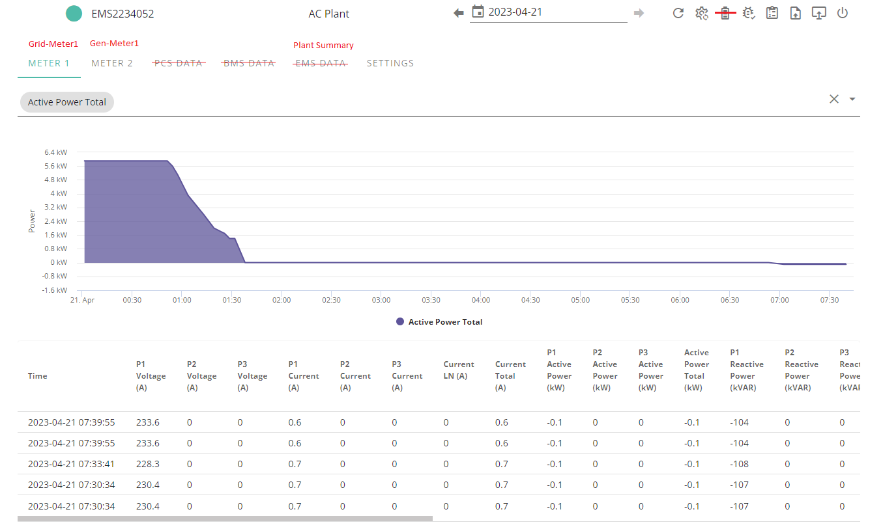

Meter screen requirements
As per current EMS meter screen with the following changes:
- Meter name appended with type (Gen, Grid, Load, Car)
- Active Power changed to 3 decimal places or Watts (0.001Kw or 1W)
- Correct unit reporting. E.g. P1 Voltage should be (V).

Firmware screen requirements
As per the current EMS firmware screen with the following changes:
- EMS ARM version number pulled from Holding register 21.
- WiFI Module ARM version number pulled from Custom modbus command:
Server sends “30 31 34 35 00 01”
Response is, “59 59 00 01 00 0E 01 02 46 4F 32 32 33 34 47 30 35 32 03 01”
Firmware version in this example is 0x301 or 769
- Remove EMS DSP and Battery ARM from page

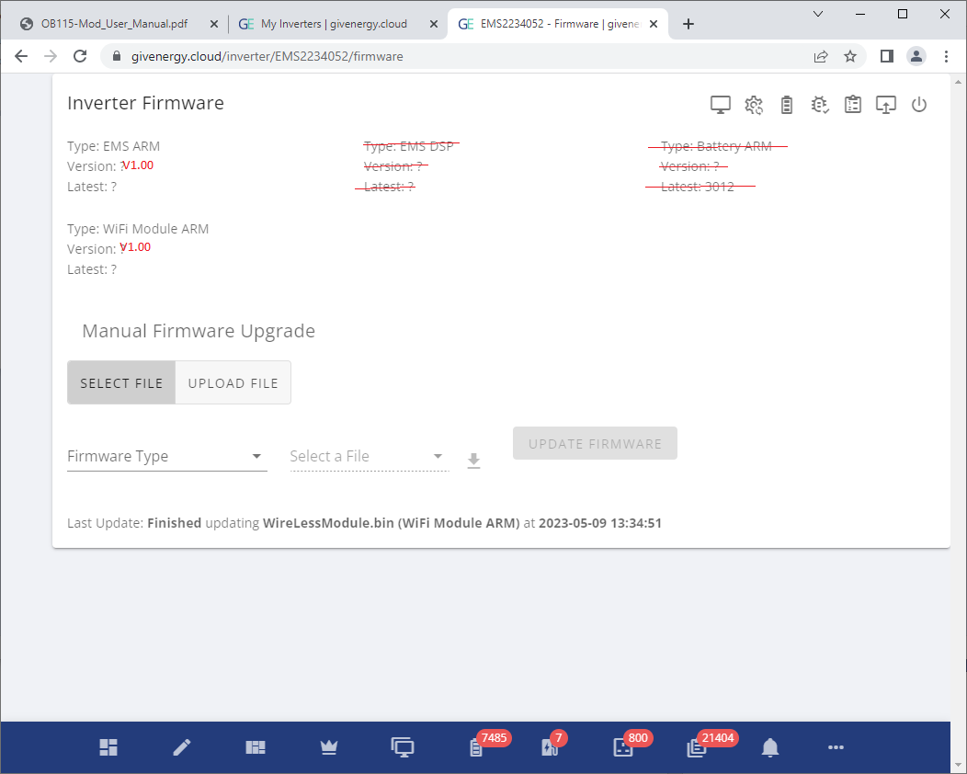

“Plant Summary” screen requirements

Summary information:
- Plant controller status – As per modbus register 2040.
- Plant inverters detected, Inverter Status, and serial numbers. Modbus registers: 2044, 2045, 2066-2085
- Plant controller warnings. Could be a hex string initially. Modbus register 2092
- Plant controller errors. Could be a hex string initially. Modbus register 2093

Graphical information:
A graph containing:
- Meter 1 Active Power – Modbus register 2046. Only display if meter not disabled in modbus register 2042.
- Meter 2 Active Power – Modbus register 2047. Only display if meter not disabled in modbus register 2042.
- Meter 3 Active Power – Modbus register 2048. Only display if meter not disabled in modbus register 2042.
- Meter 4 Active Power – Modbus register 2049. Only display if meter not disabled in modbus register 2042.
- Meter 5 Active Power – Modbus register 2050. Only display if meter not disabled in modbus register 2042.
- Meter 6 Active Power – Modbus register 2051. Only display if meter not disabled in modbus register 2042.
- Meter 7 Active Power – Modbus register 2052. Only display if meter not disabled in modbus register 2042.
- Meter 8 Active Power – Modbus register 2053. Only display if meter not disabled in modbus register 2042.
- Inverter_XXXXXXXXXX Active Power - Modbus register 2054. Only display if inverter serial number is not 0x0000000000 (Modbus registers 2066-2070). XXXXXXXXXX is the inverter serial number
- Inverter_XXXXXXXXXX Active Power - Modbus register 2055. Only display if inverter serial number is not 0x0000000000 (Modbus registers 2070-2075). XXXXXXXXXX is the inverter serial number
- Inverter_XXXXXXXXXX Active Power - Modbus register 2056. Only display if inverter serial number is not 0x0000000000 (Modbus registers 2076-2080). XXXXXXXXXX is the inverter serial number
- Inverter_XXXXXXXXXX Active Power - Modbus register 2057. Only display if inverter serial number is not 0x0000000000 (Modbus registers 2081-2085). XXXXXXXXXX is the inverter serial number
- Inverter_XXXXXXXXXX SOC - Modbus register 2058. Only display if inverter serial number is not 0x0000000000 (Modbus registers 2066-2070). XXXXXXXXXX is the inverter serial number
- Inverter_XXXXXXXXXX SOC - Modbus register 2059. Only display if inverter serial number is not 0x0000000000 (Modbus registers 2070-2075). XXXXXXXXXX is the inverter serial number
- Inverter_XXXXXXXXXX SOC - Modbus register 2060. Only display if inverter serial number is not 0x0000000000 (Modbus registers 2076-2080). XXXXXXXXXX is the inverter serial number
- Inverter_XXXXXXXXXX SOC - Modbus register 2061. Only display if inverter serial number is not 0x0000000000 (Modbus registers 2081-2085). XXXXXXXXXX is the inverter serial number
- Inverter_XXXXXXXXXX Temp - Modbus register 2062. Only display if inverter serial number is not 0x0000000000 (Modbus registers 2066-2070). XXXXXXXXXX is the inverter serial number
- Inverter_XXXXXXXXXX Temp - Modbus register 2063. Only display if inverter serial number is not 0x0000000000 (Modbus registers 2070-2075). XXXXXXXXXX is the inverter serial number
- Inverter_XXXXXXXXXX Temp - Modbus register 2064. Only display if inverter serial number is not 0x0000000000 (Modbus registers 2076-2080). XXXXXXXXXX is the inverter serial number
- Inverter_XXXXXXXXXX Temp - Modbus register 2065. Only display if inverter serial number is not 0x0000000000 (Modbus registers 2081-2085). XXXXXXXXXX is the inverter serial number
- Load Power - Modbus register 2086
- Generation Power - Modbus register 2088
- Grid Power - Modbus register 2089
- Battery Power - Modbus register 2090
- BatteryWh - Modbus register 2091
- Car charge Power – Modbus register 2094

“Plant Settings” screen requirements
All initial portal settings values to be taken from the most recent holding register response (0x03), or write (0x06) response. The plant controller will automatically transmit holding registers 0-59 and 2040-2099 periodically.



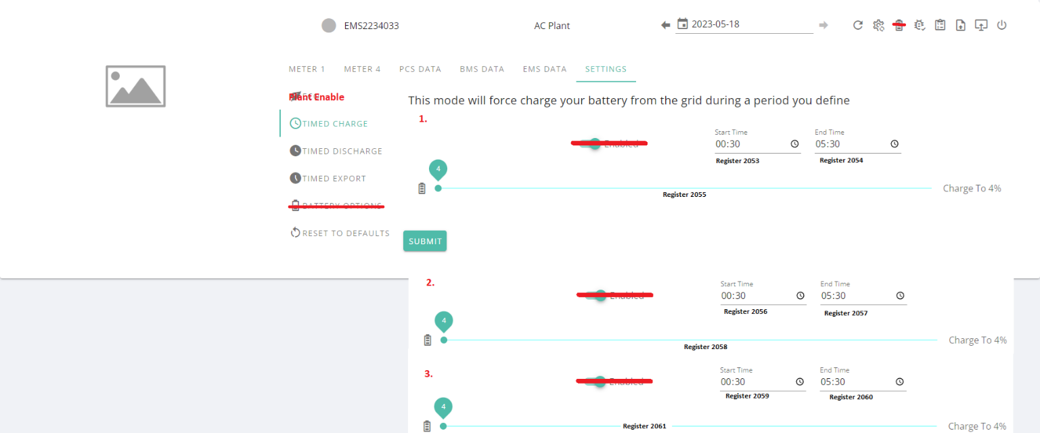
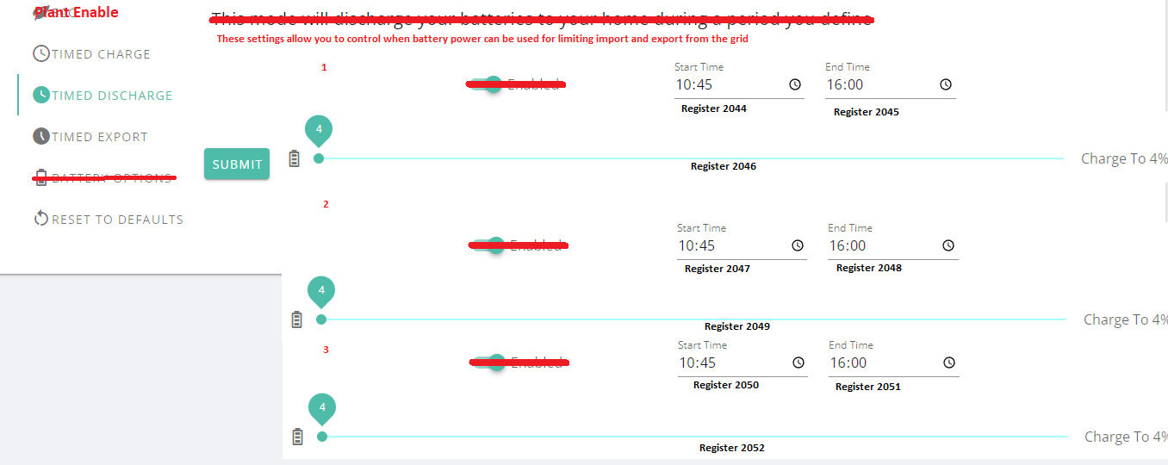

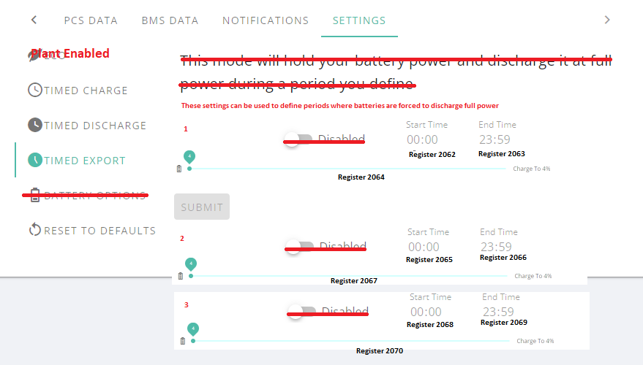
Remove “Battery Options”

“Commission/Debug” screen requirements

All initial values to be taken from the most recent holding register response (0x03), or write (0x06) response. The plant controller will automatically transmit holding registers 0-59 and 2040-2099 periodically. The plant controller will automatically transmit input registers 0-59 and 2040-2099 periodically.

Status Information:
Section | Item | Register Type | Register Number
Time | Latest Data Point Time | N/A | N/A
Plant | Plant Controller is Online | Input (Command 4) | 2040
 | Plant Controller Enabled | Holding (Command 3) | 2040
 | Active Alarms | Input (Command 4) | 2093
 | Active Warnings | Input (Command 4) | 2092
 | Firmware Version | Holding (Command 3) | 21
 | Configured Meter Count | Holding (Command 3) | 2042
 | Current Grid Meter Count | Input (Command 4) | 2042 and 2043
 | Current Gen Meter Count | Input (Command 4) | 2042 and 2043
 | Current Load Meter Count | Input (Command 4) | 2042 and 2043
 | Current Battery Meter Count (Vehicle) | Input (Command 4) | 2042 and 2043
 | Configured Inverter Count | Holding (Command 3) | 2041
 | Current Inverter Count | Input (Command 4) | 2044
 | Uptime | Input (Command 4) | 47-48
 | Inverter 1 | Input (Command 4) | 2066-2070 Display as a link so support can click and view the individual inverter
 | Inverter 2 | Input (Command 4) | 2071-2075 Display as a link so support can click and view the individual inverter
 | Inverter 3 | Input (Command 4) | 2076-2080 Display as a link so support can click and view the individual inverter
 | Inverter 4 | Input (Command 4) | 2081-2086 Display as a link so support can click and view the individual inverter
Home | Load Power | Input (Command 4) | 2086
Grid | Grid Active Power | Input (Command 4) | 2089
Giv Battery | Plant Battery Capacity | Input (Command 4) | 2091
 | Plant Battery Active Power | Input (Command 4) | 2090
Generation | Generation Active Power | Input (Command 4) | 2088
Vehicle | Vehicle Active Power | Input (Command 4) | 2094

Settings
Name | Register(s). Holding (3) to read. Single write(6) to write. | Notes
Set Date and Time | 35-40 | Button
Plant Meter Count | 2042 | 1 - 8 pull down
Plant Inverter Count | 2041 | 1 – 4 pull down
Plant Car Charger Count | 2043 | 0 – 2 pull down
Restart Inverter | 53 | Button.
Plant Enable | 2040 | Slider on/off
Battery Discharge Start 1 | 2044 | time
Battery Discharge End 1 | 2045 | time
Battery Discharge SOC 1 | 2046 | Slider 4-100
Battery Discharge Start 2 | 2047 | time
Battery Discharge End 2 | 2048 | time
Battery Discharge SOC 2 | 2049 | Slider 4-100
Battery Discharge Start 3 | 2050 | time
Battery Discharge End 3 | 2051 | time
Battery Discharge SOC 3 | 2052 | Slider 4-100
Battery Charge Start 1 | 2053 | time
Battery Charge End 1 | 2054 | time
Battery Charge SOC 1 | 2055 | Slider 4-100
Battery Charge Start 2 | 2056 | time
Battery Charge End 2 | 2057 | time
Battery Charge SOC 2 | 2058 | Slider 4-100
Battery Charge Start 3 | 2059 | time
Battery Charge End 3 | 2060 | time
Battery Charge SOC 3 | 2061 | Slider 4-100
Battery Export Start 1 | 2062 | time
Battery Export End 1 | 2063 | time
Battery Export SOC 1 | 2064 | Slider 4-100
Battery Export Start 2 | 2065 | time
Battery Export End 2 | 2066 | time
Battery Export SOC 2 | 2067 | Slider 4-100
Battery Export Start 3 | 2068 | time
Battery Export End 3 | 2069 | time
Battery Export SOC 3 | 2070 | Slider 4-100
Limit Grid Export Power | 2071 | numeric
Car Charge Mode | 2072 | 0 - 3 pull down (Stop, Eco, Eco+, Fast)
One Shot Car Charge Boost | 2073 | numeric
Plant Charge Compensation | 2074 | -5 – 5 pull down
Plant Discharge Compensation | 2075 | -5 – 5 pull down

Other requirements
- Rename “Inverter Information” to “Plant Information”
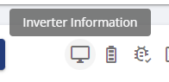
- Remove “Remote Control”


Appendix A – Current protocols

A1 GivEnergy inverter to cloud protocol V1
Givenergy Inverter Register to cloud protocol V1 1.docx

A2 GivEnergy battery to cloud protocol V1
Givenergy battery to cloud protocol V1.docx

A3 OB115 to cloud protocol V1
Givenergy 115meter to cloud protocol V1.docx

